August 27th, Design Principles

Attitude:

* What is visualization for?
  + What problem youre trying to solve? What questions do I want audience to answer by looking at this?
* What can I see here?
  + What information can I extract out of this representation?
  + How much effort is needed to extract such information?
  + How much confidence do I have in this information?
* What is an alternate solution for this problem / data?
  + Most important skill!
  + 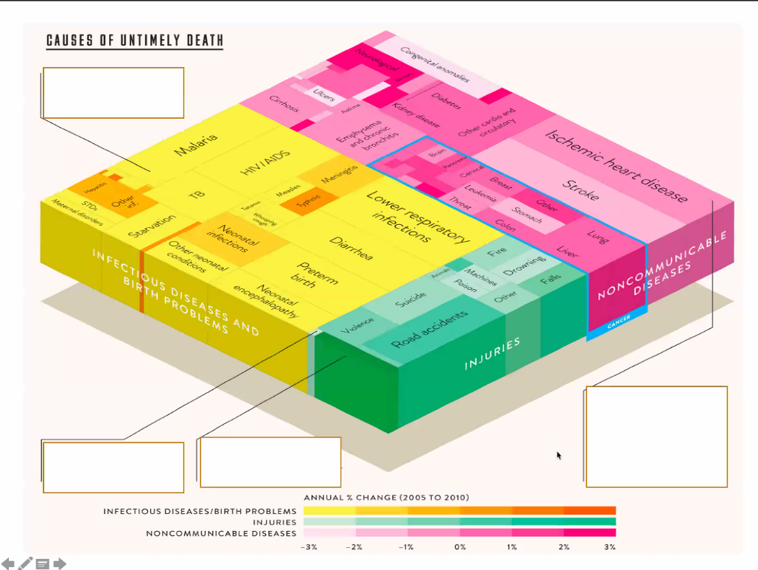Think about alternate solutions, do not be satisfied with first thing that comes into your mind
* What info can I extract?
  + Non-infectious diseases, like cancer, most danger
  + Injuries very little relatively
  + Infectious diseases becoming less dangerous each year
* How easy is it?
  + Poor readability
* How certain am I of that info?
  + Perception makes closer things look bigger
* How can I improve it?
  + Make it 2d…

Graphical Integrity

* Charts can like
* History:
  + 1930-1970: Graphs seen as a way to lie to the ignorant
  + Late 1960s: Half a dozen new designs with applicative studies without deceptions or forcing “graphical standards” (John Tukey)
  + Nowadays: Human beings are biased
* Show DATA variation, not DESIGN variation
* Number of info carrying di
* IF STUDYING CHECK SLIDES!
* Data graphics should draw attention to the sense and substance of the data, not to something else. “Ink” should be dedicated to data